- Install IDEand Burn Firmware
Program the Pico: You could use C/C++ or MicroPython. MicroPython is an interpreted language that is made specifically for microcontrollers. Many microcontroller users have familiarity with C/C++ as they are used on the Arduino and ESP32 boards. In this tutorial, we will use Thonny recommended by Raspberry Pi. Thonny bills itself as a“Python IDE for Beginners”, and it is available for Windows, Mac OSX and Linux. It is also a part of the Raspberry Pi operating system(formerly Raspbian).

Boot and Install MicroPython: The first thing we need to do is to get MicroPython installed onto the Pico.

Download and Burn Firmware
Go to the official website to download the UF2 file:
https://www.raspberrypi.com/documentation/microcontrollers/#getting-started-with-micropython
What I downloaded is . Once the download is complete, we proceed to burn the firmware.
With BOOTSEL held down, then plug the Pico into Raspberry Pi or your computer’s USB port.
Release it after the connection was finished. You should see a drive appearing on your computer with the name“RPI-RP2”.
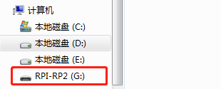
Move the UF2 file into“RPI-RP2”, and the Raspberry Pi Pico will automatically restart.

Download and Install Thonny IDE
Enter the official website to download Thonny, we should download the latest version for Windows.
Link: https://thonny.org/

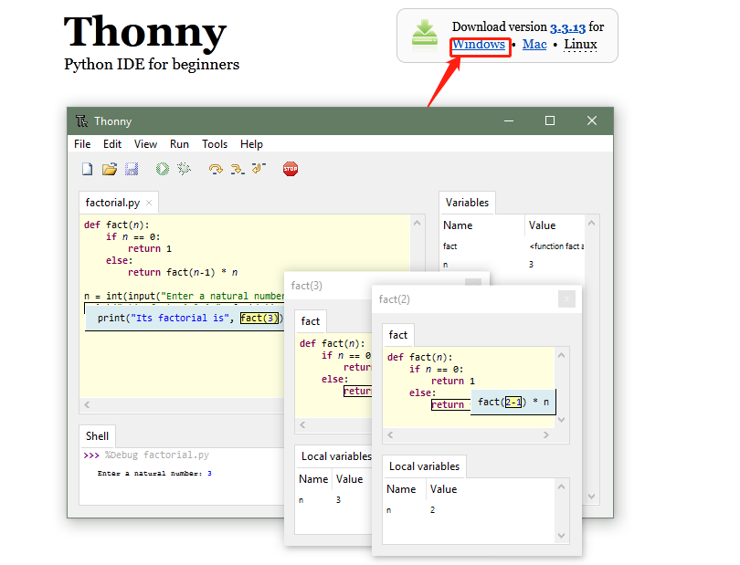
After downloading, we start installing the software. Click“Next”, then click "I accept the agreement" and click“Next”again. After that, we choose "Create desktop icon" and click“Next”, or just click "Next" to go to the next step (you can open the file in the corresponding folder).

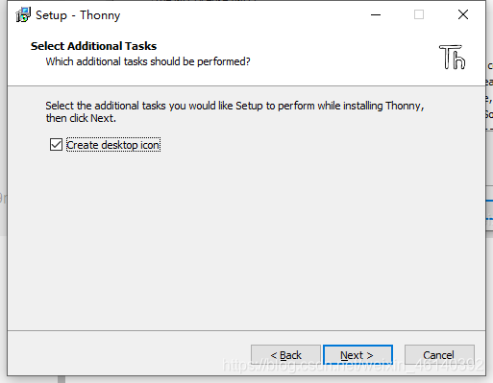
When we see the contents shown below, click "Install" to complete the installation.
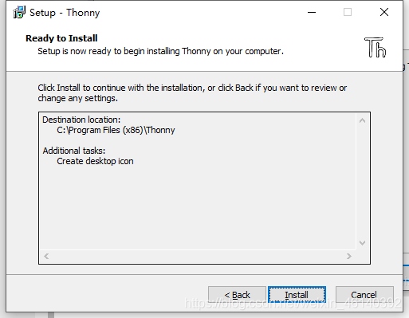
Finally, click "Finish".

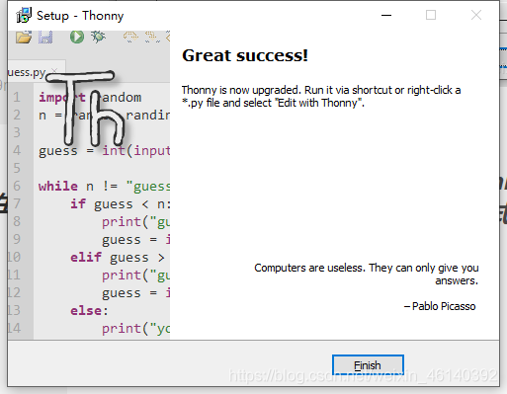
Now we run the Thonny software. First, choose the language we need and “Raspberry Pi”in“Initial settings”, then click“Let’s go!”.

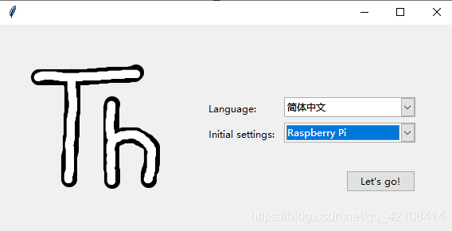
Next, we will see the interface as shown below.

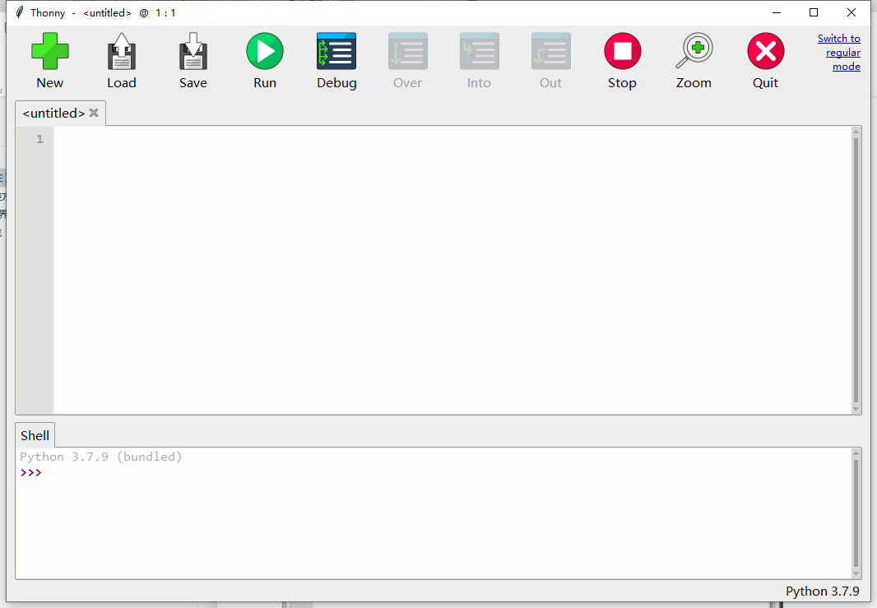

Click on the text in the top right of the window to switch to "Regular Mode". Then restart the program, the interface will be like this as illustrated below.

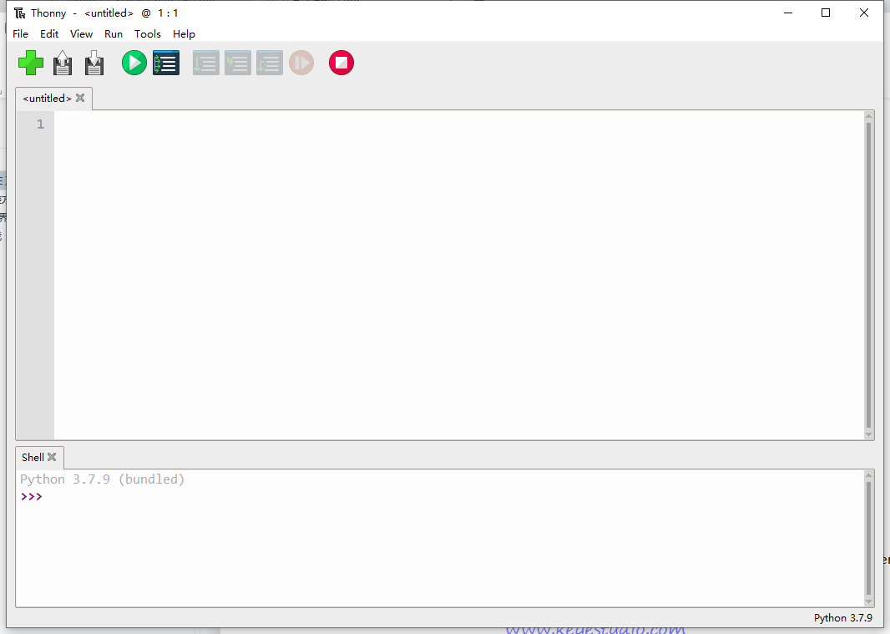
Click on the word“Python”followed by a version number at the lower right corner of the Thonny window, then choose“MicroPython (Raspberry Pi Pico)”.

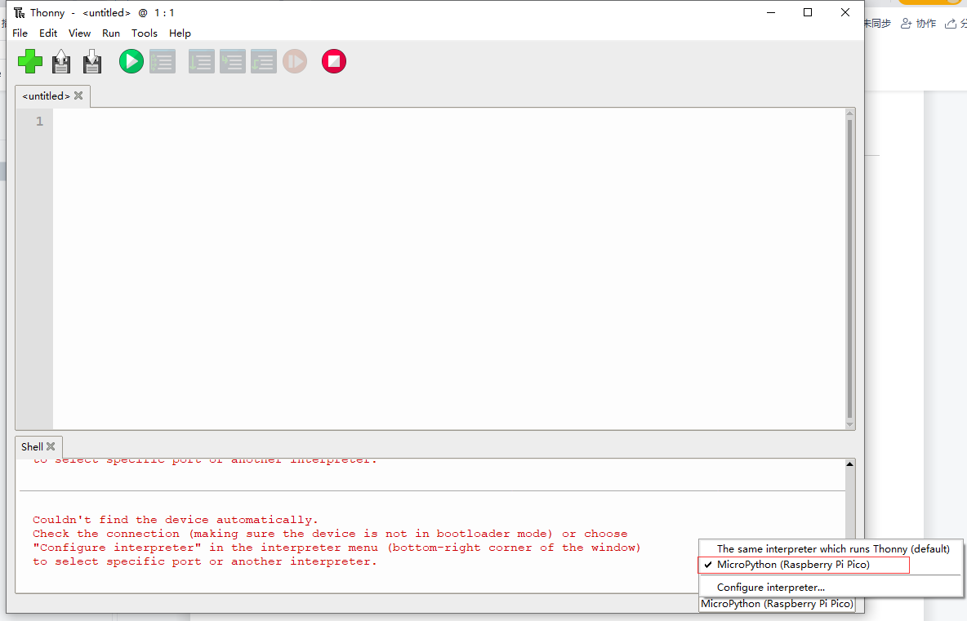
The Raspberry Pi Pico interpreter is only available in the latest version of Thonny. If you’re running an older version, you can’t choose the corresponding interpreter. After choosing the interpreter, the interface will be like this as follows.

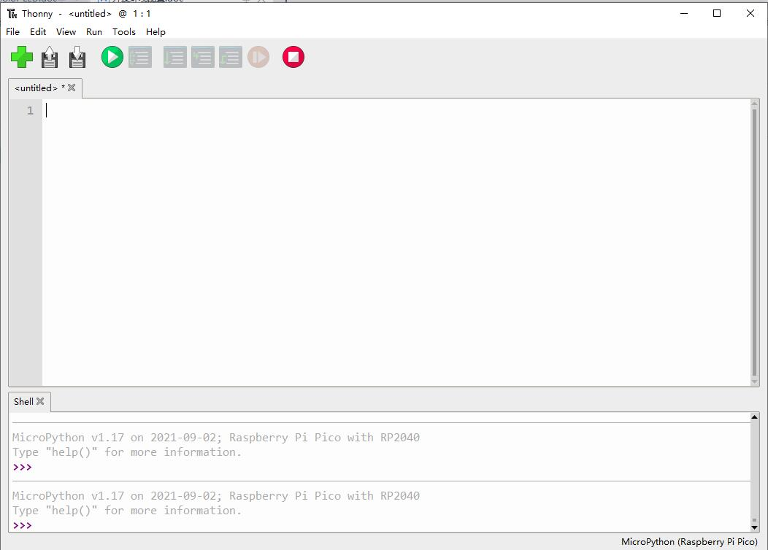

- Install Drivers
Wire the Pi Pico board with the USB port of a computer via a MicroUSB. If the Pi Pico shield has installed MicroPython, and installed“Board CDC ” on the computer, then it will shows corresponding ports of“Pi Pico Serial Port（COM）”on Device Manager. If you have a Raspberry Pi, you can connect the Pico to the Raspberry Pi directly. The Raspberry Pi has a lot of built-in software that can be used directly. If wire the Pico with the computer, please follow the steps below.
Windows 10
When plug the Pico into the computer, the system will automatically identify serial port and install corresponding driver. You can find“USB Serial”on Device Manager. On my computer is COM4. You can find the corresponding COM port in Thonny options (Tools-Options-Interpreter).

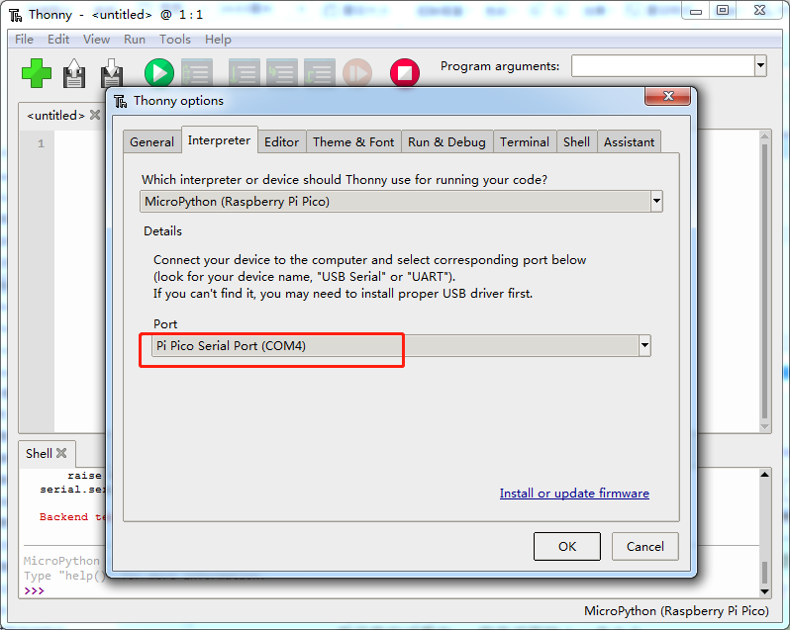
If it shows the following information, indicating that your Pico board is successfully connected to the computer.
MicroPython v1.17 on 2021-09-02; Raspberry Pi Pico with RP2040
Type “help()” for more information.
Then we input the following command behind >>>.
machine.Pin(25, machine.Pin.OUT).value(1)
Press“Enter”, if the on-board LED lights up, it means that Thonny works.

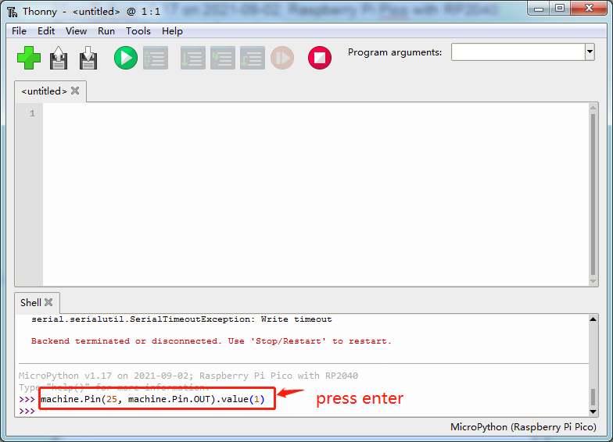
If you're still running Windows 7, when you plug the Raspberry PI Pico into the USB port, your computer will find a "Board CDC" device, but it can't automatically recognize it or install drivers.
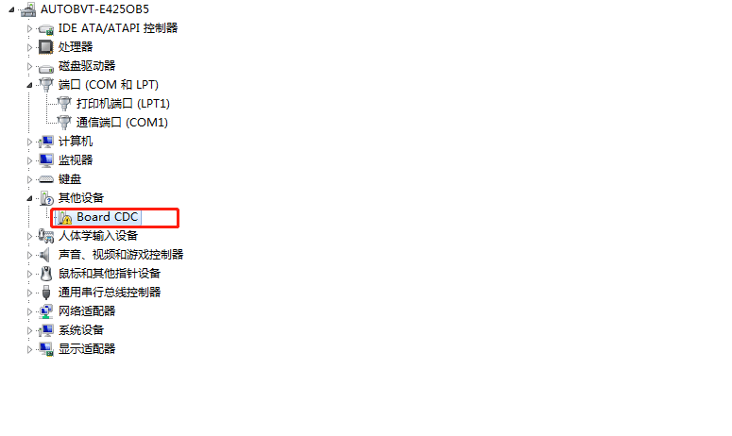
First find the file named "Board CDC_RP2_pico-serial.inf", this file format is the driver file, then in device manager, manually add the driver to the unrecognized device. Open device manager on your computer: double-click or right-click on the hardware to update the driver.
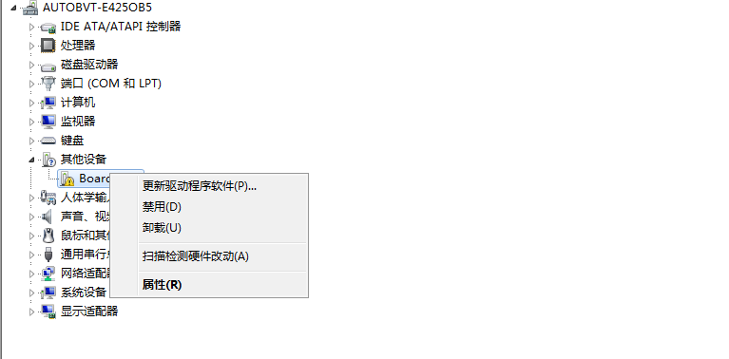
Browse the computer for drivers
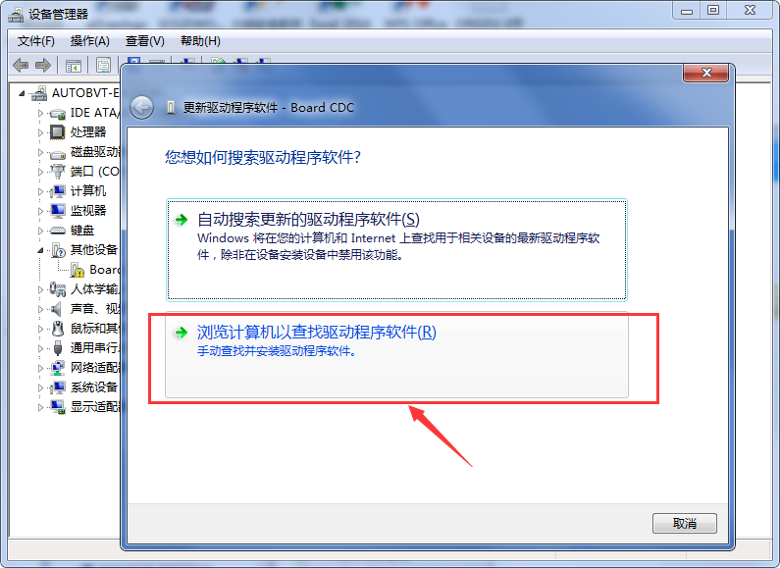
Assuming that our driver file is on the desktop, we find the folder corresponding to the file and click Next
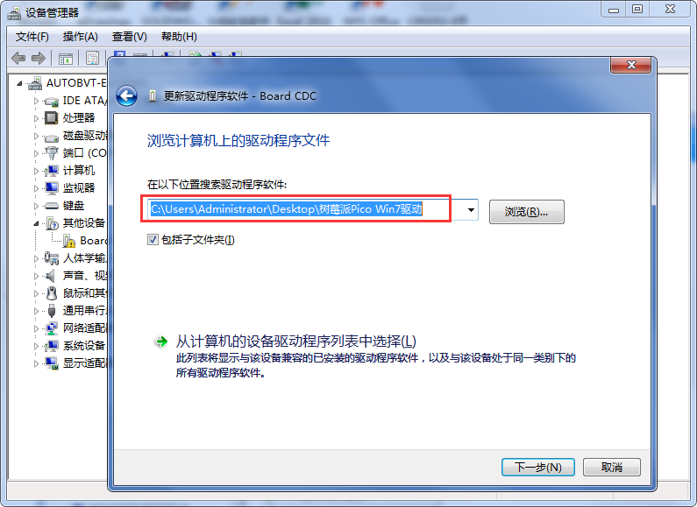

Select this folder and click OK to install the driver successfully.

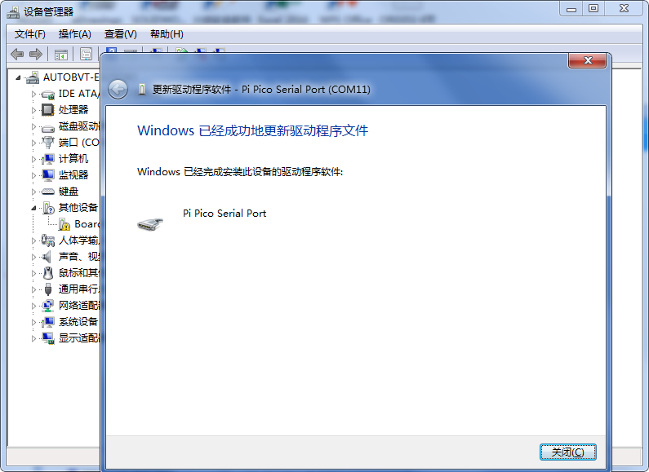
Open the device manager, we can see that the PI Pico driver has been successfully installed, the PI Pico Serial Port appears.
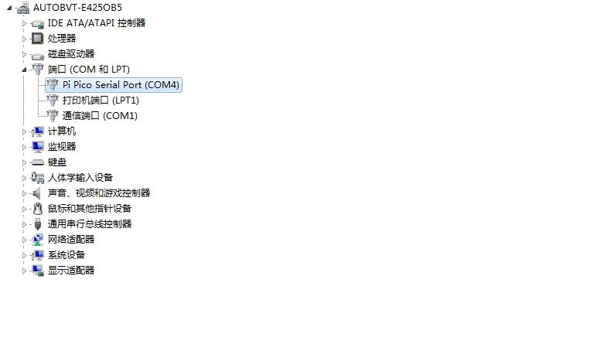

- Thonny Interface
After installing the IDE and the driver, now we will introduce how to use the Thonny. At the top is the main menu, there are“File”,“Edit”,“View”, “Run”,“Tools”and“Help”.

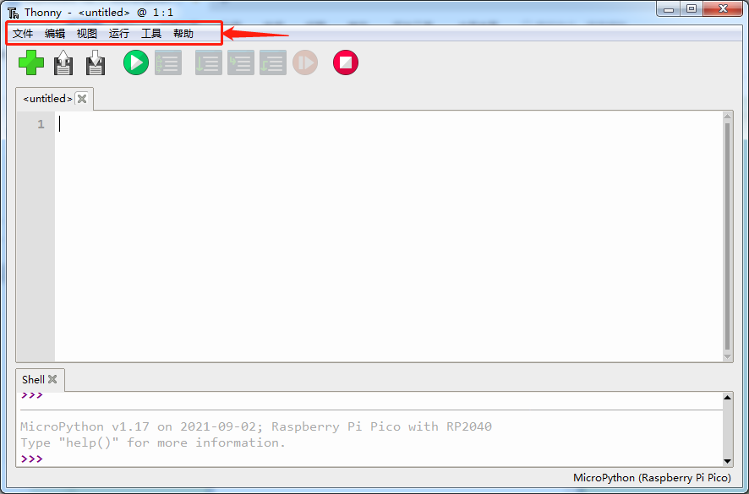
Click“File”, it shows some operations related to files.

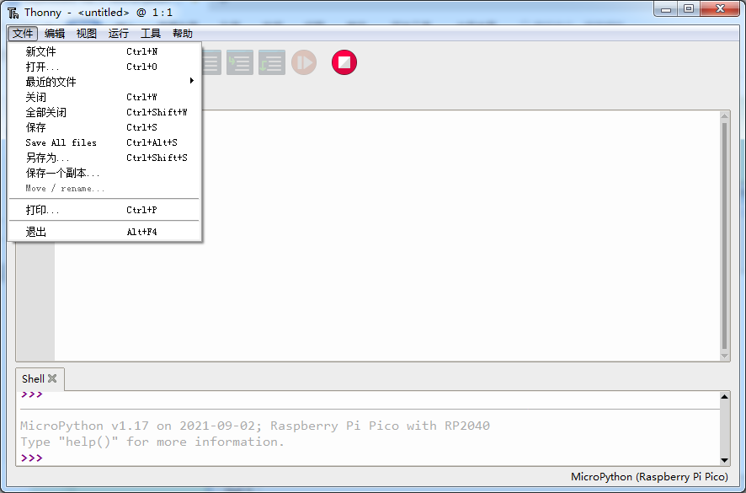
Click“Edit”, these are some options about code, such as copying, cutting, pasting.
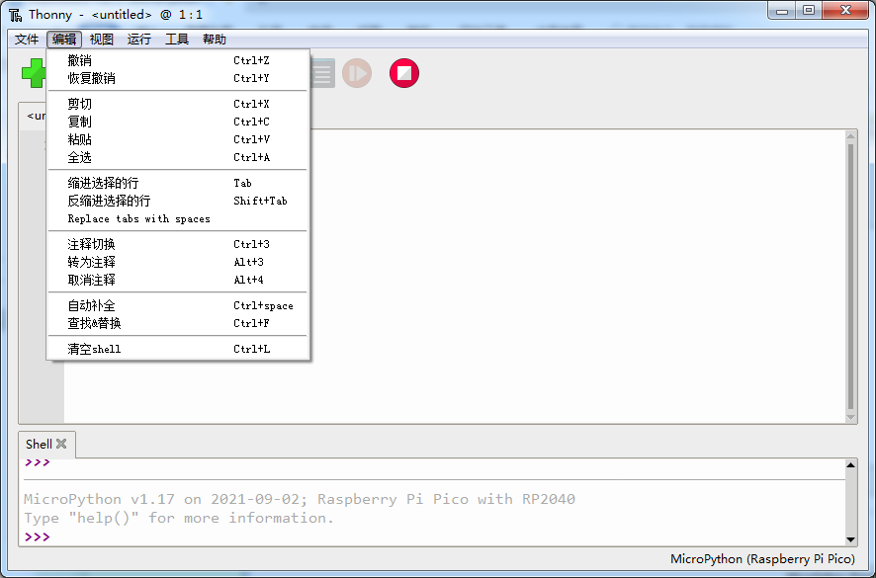
In the View drop-down menu, these are the tools to assist you. For example, if we do not tick Shell (the Shell is the“command line”of the Pico, and you can execute code directly here.), the result won’t be displayed. Click “Files”, the files we saved will be shown on the left.
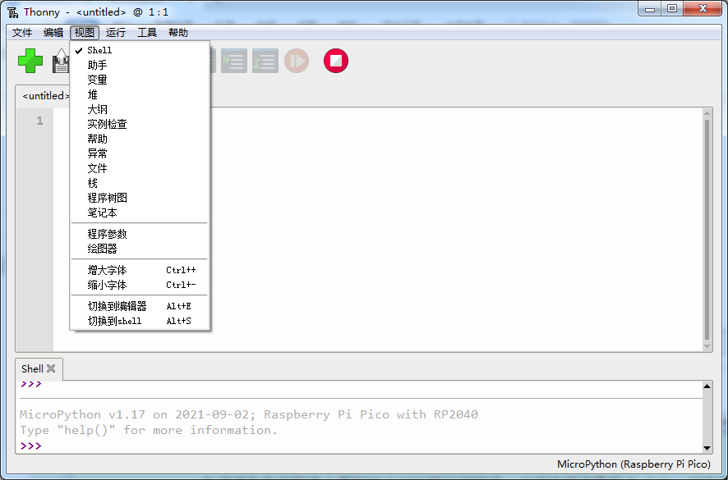
We can select interpreter in the Run drop-down menu, there are also some shortcuts used in programming.

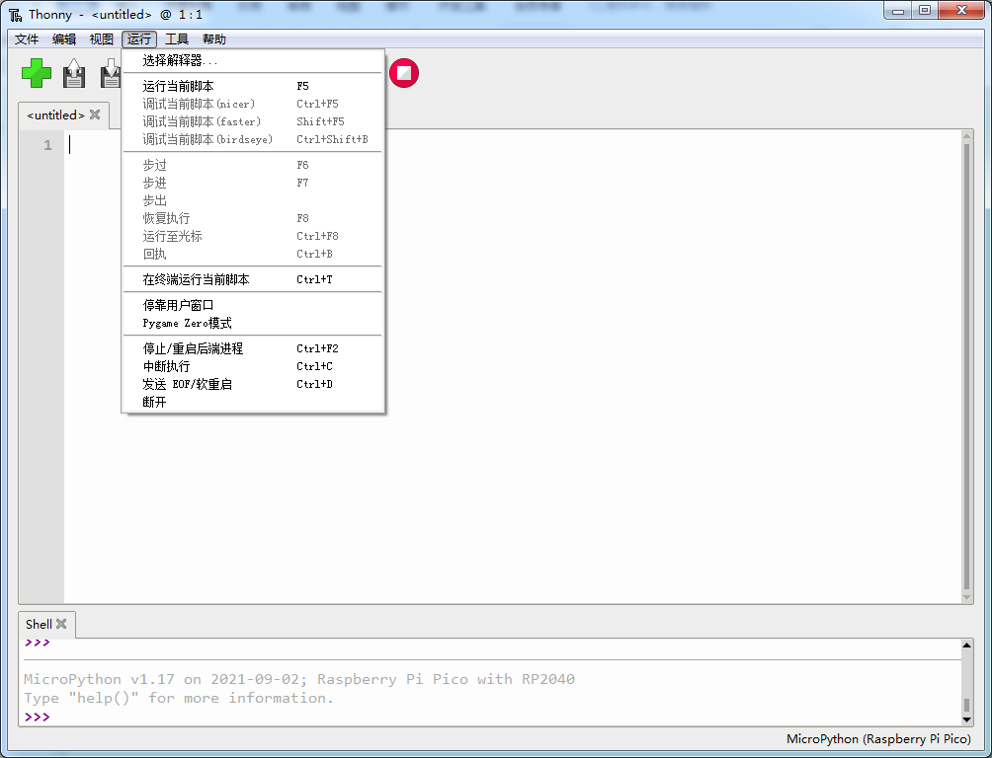
In Tools menu, we can select interpreter, font and import modules, etc.

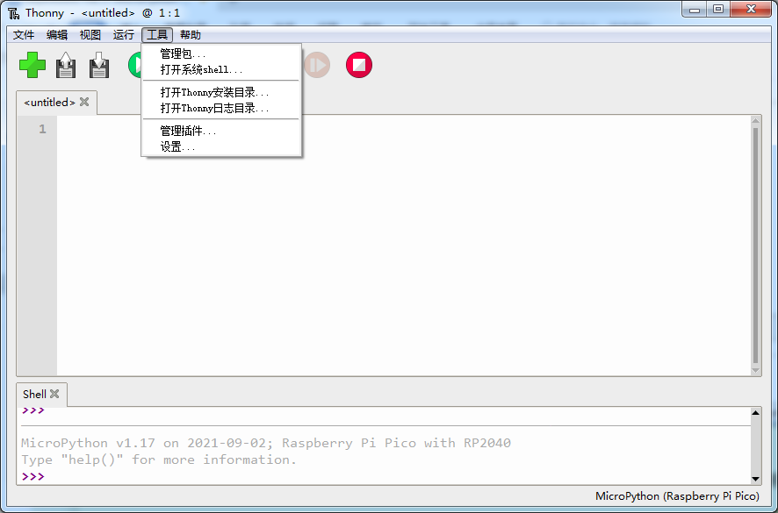
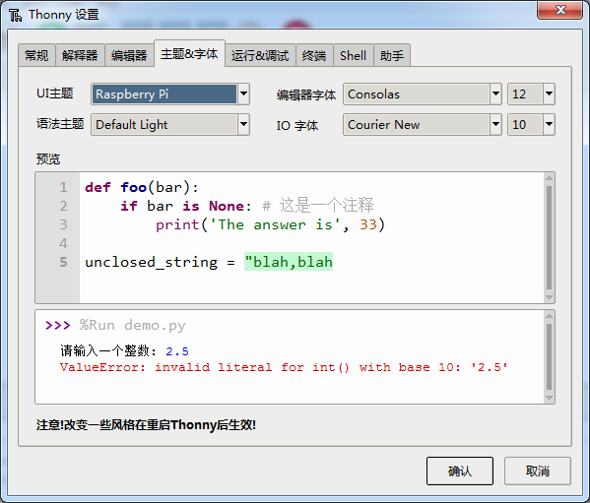
In Help menu, we will see“Help contents”,“Version history”and more.
The icons below the main menu are our commonly used tool shortcuts.
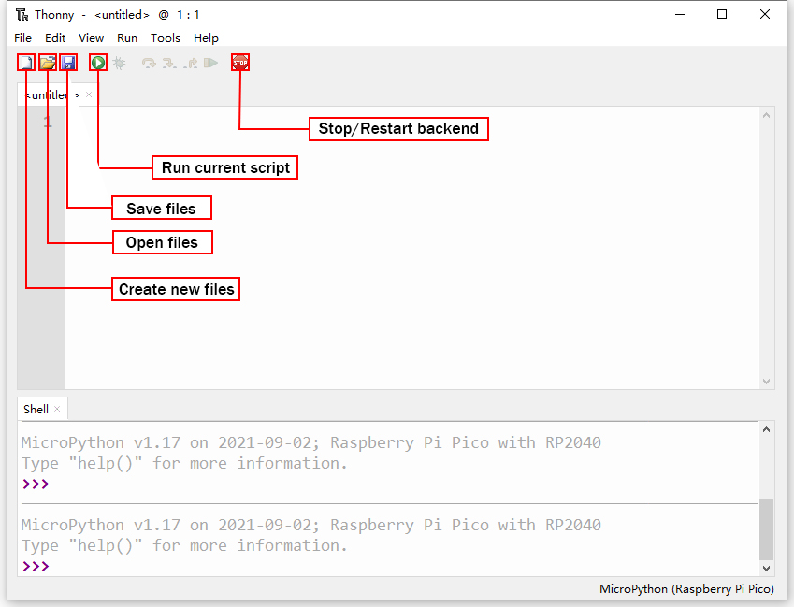
When we open or save files, it will shows the following contents.
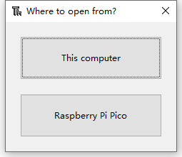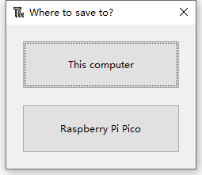

We can open programs saved on the computer or the Pico, or save them on This computer or Raspberry Pi Pico.
Copy the code below to the Thonny and save it to the computer as test.py.
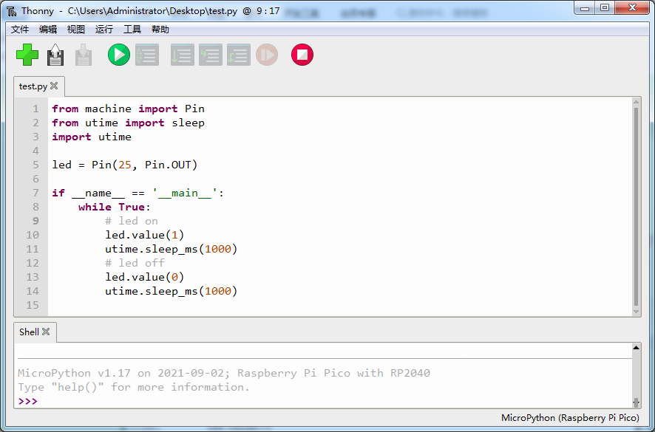
Click  to run the code, the on-board LED will blink at 1 second intervals, then click  to stop, the LED won’t blink. If we unplug the MicroUSB cable and plug it in again, the LED won’t blink after powering up. This is because we did not name the file main.py and save it to the Pico. Click“File”, then click“Save as...”to choose Raspberry Pi Pico. After that, enter main.py as the file name (don’t forget to enter the .py file extension) and click“OK”. Run the code again, the LED will continue to blink.

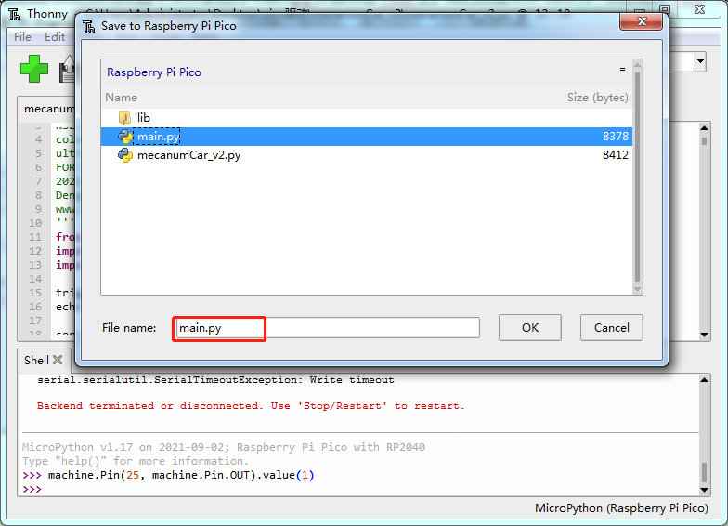
When we unplug the cable again, then plug it in and power on, the LED will blink. This is because the Raspberry Pi Pico starts running the program saved on main.py after powering up.

4. Add Modules

Python is a powerful language due to its modules. Python scripting language contains the most rich and powerful class library, which is enough to support the vast majority of day-to-day applications. By importing modules, making it easier for us to use some complex sensors.
The method is simple, just save the module that we need to the Pico, or open the file saved on our computer, click“File”to choose“Save as”, then save it to the Pico board (right click the mouse, you can delete files). For instance, I saved some library files required for these courses on my Pico. Click“View”to choose“Files”, they will be displayed on the left of the interface.
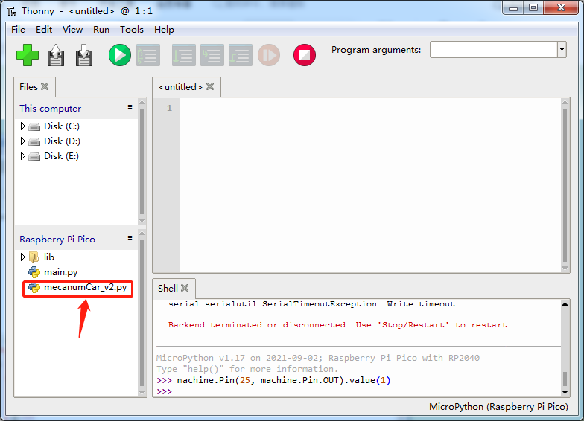
When using sensors, we can import the corresponding modules directly.

